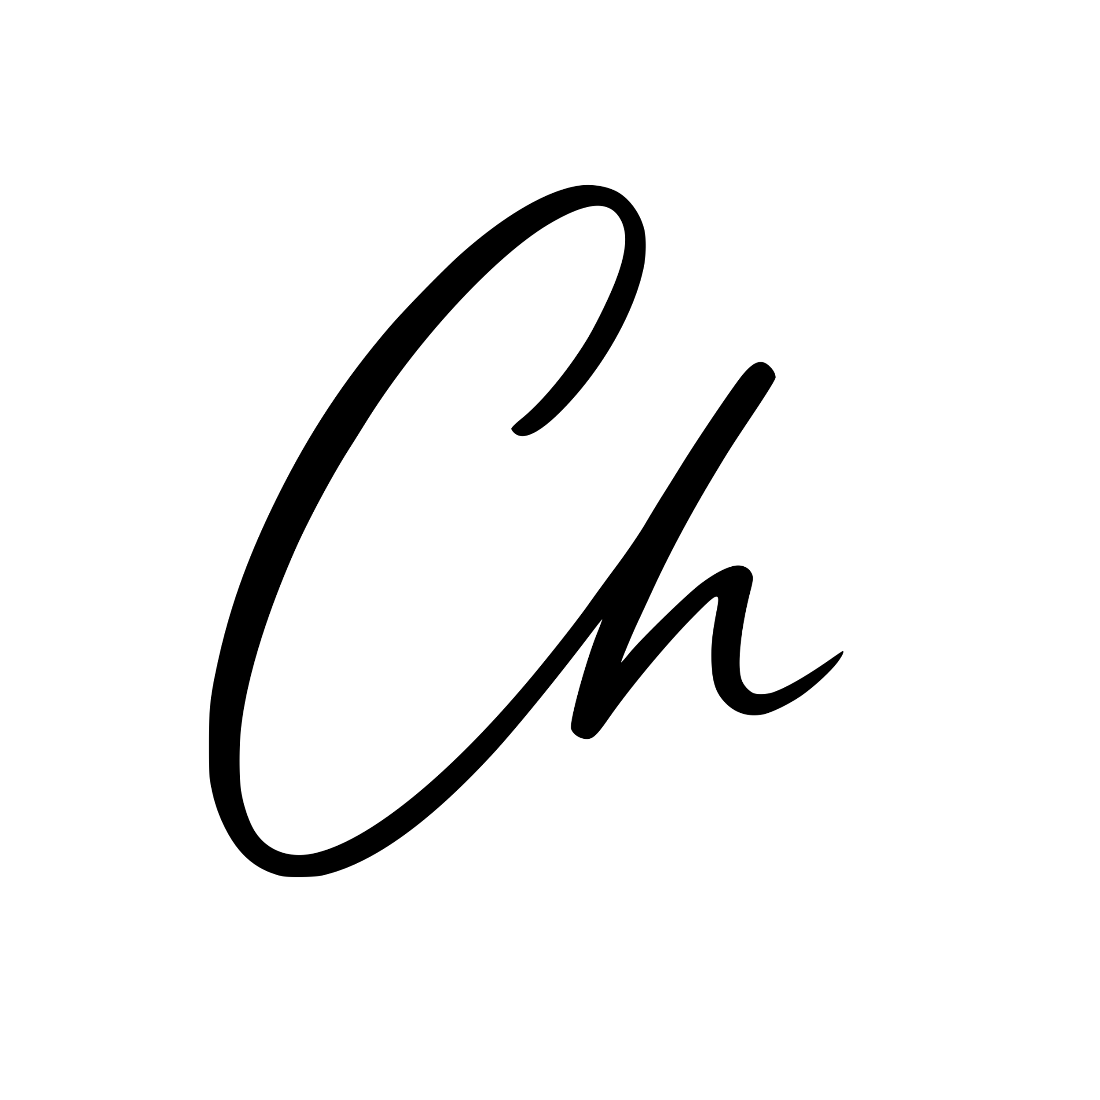 **| CHETAN LOHIA**

**To,**  
.NP ccTLD Registry  
Mercantile Communications Pvt. Ltd.  
Hiti Pokhari, Durbarmarg,  
P. O. Box 66, Kathmandu, Nepal

**Subject:** Application for Registration of Domain Name – chetanlohia.com.np

Dear Sir/Madam,

I am writing to formally request the registration of the domain name **chetanlohia.com.np** under the .NP country-code top-level domain.

I am a Nepalese citizen and wish to use this domain for personal and professional purposes, including creating a personal website, showcasing my portfolio, and managing email communication. The domain name reflects my legal name and is intended solely for non-commercial use.

Please find the required documents attached with this application, including:

* A scanned copy of my Nepalese citizenship certificate
* This cover letter

I kindly request you to process this application at your earliest convenience. Should you require any further information or documentation, please feel free to contact me.

Thank you for your time and assistance.

Sincerely,  
**Chetan Lohia**  
Ravibhawan, Kathmandu-14  
[official.clohia@gmail.com](mailto:official.clohia@gmail.com)  
+977-9863330302